# Patching the Nano Every Serial Interface

There is a problem with early “Arduino Nano Every” serial interfaces. While it works fine once started, it does not properly start up if it was plugged into USB when the PC was booted. This means you can’t leave it plugged in.

The problem has been traced and fixed, circa September 2019. New Arduino Nano Every units, once initial stocks have been cleared, will have the correct code. For early modules a reprogramming activity is needed: but is in a second microcontroller chip which requires non-standard programming.

The problem is evident with Andromeda front panels. You will know you have this problem if Thetis takes much longer than normal to start, and the LEDs on Andromeda don’t work. You can verify by closing Thetis, removing the USB plug then plugging back in and restarting thetis. If your LEDs now work normally you have this problem.

To fix it you will need to follow this process:

1. Download a program called “bossac.exe” from this location: <https://www.mattairtech.com/software/arduino/bossac-1.7.0-mattairtech-2-mingw32-64.zip>
2. Download the binary file (MuxTo.bin) for the microcontroller from here: <https://github.com/arduino/ArduinoCore-megaavr/blob/master/firmwares/MuxTO/MuxTO.bin>
3. Extract the files into a suitable folder eg C:\documents\fix_my_nano
4. Remove power from your Arduino Nano Every
5. Disconnect all USB ports that could have a serial interface device on them (eg other Arduinos)
6. Remove the USB cable from your Arduino Nano Every
7. Short the two pads underneath the Arduino as shown (eg with tweezers) and re-connect USB
8. Once USB has connected (the PC will beep) the short can be removed.
9. Open a terminal window (cmd.exe) and change directory to your folder containing bossac.exe and MuxTo.bin
10. Execute this command: **bossac -U true -i -e -w -v MuxTO.bin –R**
11. Your Arduino Nano Every serial interface should be reprogrammed!
12. Remove USB, then re-connect without the short and your Arduino should now work normally

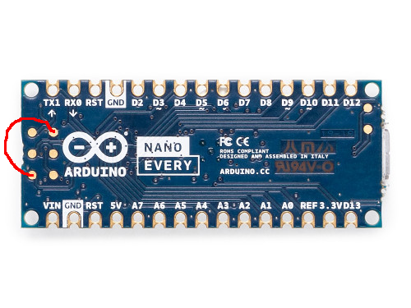

If you are unable to disconnect all other USB serial devices, it will be necessary instead to tell the program which COM port to program.

1. After plugging in with the shorting link applied, note the COM port number that has been assigned (this will be different from the normal one you get for your Nano Every)
2. Execute this command: **bossac --port=portname -U true -i -e -w -v MuxTO.bin –R** (replacing portname by **COM3** for example)